<!DOCTYPE html>

<html lang="en">

<head>

<title>Bootstrap Example</title>

<meta charset="utf-8">

<meta name="viewport" content="width=device-width, initial-scale=1">

<link rel="stylesheet" href="https://maxcdn.bootstrapcdn.com/bootstrap/4.1.0/css/bootstrap.min.css">

<script src="https://ajax.googleapis.com/ajax/libs/jquery/3.3.1/jquery.min.js"></script>

<script src="https://cdnjs.cloudflare.com/ajax/libs/popper.js/1.14.0/umd/popper.min.js"></script>

<script src="https://maxcdn.bootstrapcdn.com/bootstrap/4.1.0/js/bootstrap.min.js"></script>

</head>

<body>

<div class="container">

<div class="btn-group">

<button type="button" class="btn btn-primary">Apple</button>

<button type="button" class="btn btn-primary">Samsung</button>

<div class="btn-group">

<button type="button" class="btn btn-primary dropdown-toggle" data-toggle="dropdown">

Sony

</button>

<div class="dropdown-menu">

<a class="dropdown-item" href="#">Tablet</a>

<a class="dropdown-item" href="#">Smartphone</a>

</div>

</div>

</div>

</div>

</body>

</html>

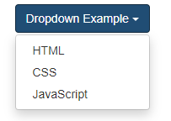

<div class="dropdown">  
<button class="btn btn-primary dropdown-toggle" type="button" data-toggle="dropdown">Dropdown Example</button>  
  <ul class="dropdown-menu">  
    <li><a href="#">HTML</a></li>  
    <li><a href="#">CSS</a></li>  
    <li><a href="#">JavaScript</a></li>  
  </ul>  
</div>

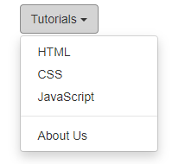

<div class="dropdown">  
  <button class="btn btn-primary dropdown-toggle" type="button" data-toggle="dropdown">Dropdown Example  
  ></button>  
  <ul class="dropdown-menu">  
    <li><a href="#">HTML</a></li>  
    <li><a href="#">CSS</a></li>

**<li class="dropdown-divider"></li>**

    <li><a href="#">JavaScript</a></li>  
  </ul>  
</div>

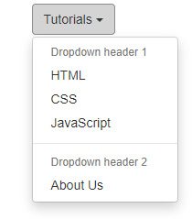

<div class="dropdown">  
  <button class="btn btn-primary dropdown-toggle" type="button" data-toggle="dropdown">Dropdown Example </button>  
  <ul class="dropdown-menu">  
**<li class="dropdown-header">Dropdown header 1</li>**

<li><a class="dropdown-item" href="#">HTML</a></li>  
<li><a class="dropdown-item" href="#">CSS</a></li>

**<li class="dropdown-divider"></li>**

**<li class="dropdown-header">Dropdown header 2</li>**

    <li><a class="dropdown-item" href="#">JavaScript</a></li>  
  </ul>  
</div>

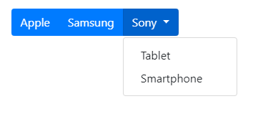

<div class="btn-group">  
  <button type="button" class="btn btn-primary">Apple</button>  
  <button type="button" class="btn btn-primary">Samsung</button>  
  <div class="btn-group">  
    <button type="button" class="btn btn-primary dropdown-toggle" data-toggle="dropdown">   
       Sony  
    </button>  
    <div class="dropdown-menu">  
      <a class="dropdown-item" href="#">Tablet</a>  
      <a class="dropdown-item" href="#">Smartphone</a>  
    </div>  
  </div>  
</div>

Открытие div по нажатию.

<button data-toggle="collapse" data-target="#demo">Collapsible</button>  
  
<div id="demo" class="collapse">  
Lorem ipsum dolor text....  
</div>

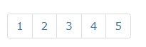

<ul class="pagination pagination-sm">

<li class="page-item"><a class="page-link" href="#">1</a></li>

<li class="page-item"><a class="page-link" href="#">2</a></li>

<li class="page-item"><a class="page-link" href="#">3</a></li>

<li class="page-item"><a class="page-link" href="#">4</a></li>

</ul>

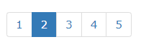

<ul class="pagination pagination-sm">

<li class="page-item active"><a class="page-link" href="#">2</a></li>

<li class="page-item"><a class="page-link" href="#">2</a></li>

<li class="page-item"><a class="page-link" href="#">3</a></li>

</ul>



<ul class="pagination">  
  <li class="page-item"><a class="page-link" href="#">Previous</a></li>  
  <li class="page-item"><a class="page-link" href="#">1</a></li>  
  <li class="page-item"><a class="page-link" href="#">2</a></li>  
  <li class="page-item"><a class="page-link" href="#">3</a></li>  
  <li class="page-item"><a class="page-link" href="#">Next</a></li>  
</ul>



<ol class="breadcrumb">

<li class="breadcrumb-item"><a href="#">Home</a></li>

<li class="breadcrumb-item"><a href="#">Library</a></li>

<li class="breadcrumb-item active" aria-current="page">Data</li>

</ol>